1. 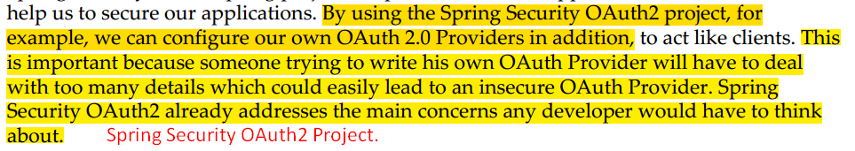  
   Spring Security Oauth2 Project: To create Oauth 2.0 Provider = Authorization Server + Resource Server.
2. 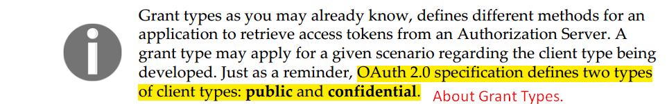  
   **Public Grant Type**: Access token is exposed in browser/mobile app.  
   **Confidential Type**: Access token remains in the server side.
3. Facebook URL to register your app: <https://developers.facebook.com/>
4. 
5. When doing registrations, we provided the followings
   1. Client Type:
   2. Redirect URI:
   3. Application Info:
      1. Home page.
6. 